CSE3506 - Essentials of Data Analytics

Lab Task - 2(21/01/2022)

Regression(Solar Pond)

Name: Revanth Bhargava Boyidi

Reg. No.: 19BCE1177
Setting the path and Importing libraries
setwd("D:\\SEM-VI\\EDA_CSE3506\\Lab\\Lab-2(21-01)_Linear Regression")
rm(list=ls()) #To clear the environment
library(dplyr) #dplyr is a library, which has functions related to data analysis
##
## Attaching package: 'dplyr'
## The following objects are masked from 'package:stats':
##
## filter, lag
## The following objects are masked from 'package:base':
##
## intersect, setdiff, setequal, union
library("ggplot2")
Store first 5 observations (6:00-08:00 ) in ‘data1’, next 10 observations(8:30-13:00) in ‘data2’ and the last 11 observations (13:00-18:00) in ‘data3’.
data1 <- read.csv("data1.csv",header=TRUE)
data2 <- read.csv("data2.csv",header=TRUE)
data3 <- read.csv("data3.csv",header=TRUE)
(i) rbind (data1, data2)
rbind(data1, data2)
## Time T8 Twi UCZ NCZ LCZ_0 LCZ_3 LCZ_5 Two_0 Two_3 Two_5 DT1_0 DT1_3 DT1_5
## 1 6:00 29 28.0 28 28 28 28 28 28.0 28.0 28.0 0.0 0.0 0.0
## 2 6:30 29 28.0 28 28 28 28 28 28.0 28.0 28.0 0.0 0.0 0.0
## 3 7:00 29 28.0 28 28 28 28 28 28.0 28.0 28.0 0.0 0.0 0.0
## 4 7:30 30 29.0 29 29 29 29 29 29.0 29.0 29.2 0.0 0.0 0.2
## 5 8:00 30 29.0 29 30 32 32 32 29.0 29.7 30.2 0.0 0.7 1.2
## 6 08:30 30 29.0 29 31 33 33 33 30.0 30.4 30.6 1.0 1.4 1.6
## 7 09:00 30 29.0 29 32 35 35 35 30.0 30.7 31.1 1.0 1.7 2.1
## 8 09:30 31 29.0 29 33 37 37 37 30.3 31.0 31.5 1.3 2.0 2.5
## 9 10:00 31 29.0 30 35 39 39 39 31.0 31.4 32.0 2.0 2.4 3.0
## 10 10:30 32 30.0 30 36 41 41 41 32.0 32.8 33.5 2.0 2.8 3.5
## 11 11:00 33 31.0 32 37 42 42 42 33.4 33.9 34.7 2.4 2.9 3.7
## 12 11:30 34 32.0 33 36 44 44 44 34.5 35.0 36.0 2.5 3.0 4.0
## 13 12:00 35 33.0 34 37 46 46 46 35.5 36.2 37.0 2.5 3.2 4.0
## 14 12:30 36 34.0 35 38 48 48 48 36.5 37.5 38.4 2.5 3.5 4.4
## 15 13:00 36 34.4 36 39 50 50 50 37.5 38.0 39.5 3.1 3.6 5.1
## Qact_0 Qact_3 Qact_5 Pyranometer..Reading_April Pyranometer..Reading_May
## 1 0.00 0.00 0.00 200 210
## 2 0.00 0.00 0.00 260 280
## 3 0.00 0.00 0.00 290 300
## 4 0.00 0.00 5.80 312 320
## 5 0.00 20.30 34.80 340 360
## 6 31.40 43.96 50.24 390 420
## 7 31.40 53.38 65.94 435 460
## 8 40.82 62.80 78.50 540 500
## 9 62.80 75.36 94.20 542 560
## 10 62.80 87.92 109.90 598 640
## 11 75.36 91.06 116.18 680 680
## 12 78.50 94.20 125.60 715 800
## 13 78.50 100.48 125.60 862 880
## 14 78.50 109.90 138.16 900 970
## 15 97.34 113.04 160.14 890 940
## Pyranometer..Reading_June Incident.Energy..........W.. X.Solar.Pond_0
## 1 NA 252 0.00
## 2 NA 336 0.00
## 3 NA 360 0.00
## 4 NA 384 0.00
## 5 NA 432 0.00
## 6 NA 504 6.23
## 7 NA 552 5.69
## 8 NA 600 6.80
## 9 NA 672 9.35
## 10 NA 768 8.18
## 11 NA 816 9.24
## 12 NA 960 8.18
## 13 NA 1056 7.43
## 14 NA 1164 6.74
## 15 NA 1128 8.63
## X.Solar.Pond_3 X X.Solar.Pond_5 X.1 DT2_0 DT2_3 DT2_5 Qmax_0 Qmax_3
## 1 0.00 0.00 0.00 0.00 0.0 0.0 0.0 0.00 0.00
## 2 0.00 0.00 0.00 0.00 0.0 0.0 0.0 0.00 0.00
## 3 0.00 0.00 0.00 0.00 0.0 0.0 0.0 0.00 0.00
## 4 0.00 0.00 1.51 1.51 0.0 0.0 0.0 0.00 0.00
## 5 4.70 4.70 8.06 8.06 3.0 3.0 3.0 87.00 87.00
## 6 8.72 2.49 9.97 3.74 4.0 4.0 4.0 125.60 125.60
## 7 9.67 3.98 11.95 6.26 6.0 6.0 6.0 188.40 188.40
## 8 10.47 3.66 13.08 6.28 8.0 8.0 8.0 251.20 251.20
## 9 11.21 1.87 14.02 4.67 10.0 10.0 10.0 314.00 314.00
## 10 11.45 3.27 14.31 6.13 11.0 11.0 11.0 345.40 345.40
## 11 11.16 1.92 14.24 5.00 11.0 11.0 11.0 345.40 345.40
## 12 9.81 1.64 13.08 4.91 12.0 12.0 12.0 376.80 376.80
## 13 9.52 2.08 11.89 4.46 13.0 13.0 13.0 408.20 408.20
## 14 9.44 2.70 11.87 5.13 14.0 14.0 14.0 439.60 439.60
## 15 10.02 1.39 14.20 5.57 15.6 15.6 15.6 489.84 489.84
## Qmax_5 Effectiveness_0 Effectiveness_3 Effectiveness_5
## 1 0.00 0.00 0.00 0.00
## 2 0.00 0.00 0.00 0.00
## 3 0.00 0.00 0.00 0.00
## 4 0.00 0.00 0.00 0.00
## 5 87.00 0.00 0.23 0.40
## 6 125.60 0.25 0.35 0.40
## 7 188.40 0.17 0.28 0.35
## 8 251.20 0.16 0.25 0.31
## 9 314.00 0.20 0.24 0.30
## 10 345.40 0.18 0.25 0.32
## 11 345.40 0.22 0.26 0.34
## 12 376.80 0.21 0.25 0.33
## 13 408.20 0.19 0.25 0.31
## 14 439.60 0.18 0.25 0.31
## 15 489.84 0.20 0.23 0.33
(ii) Store LCZ(TT=0), LCZ(TT=3), LCZ(TT=5), in variables V1, V2 and V3 respectively. Cbind all these three columns.
df <- rbind(data1, data2, data3)
V1 <- df$LCZ_0
V2 <- df$LCZ_3
V3 <- df$LCZ_5
cbind(V1, V2, V3)
## V1 V2 V3
## [1,] 28 28.0 28
## [2,] 28 28.0 28
## [3,] 28 28.0 28
## [4,] 29 29.0 29
## [5,] 32 32.0 32
## [6,] 33 33.0 33
## [7,] 35 35.0 35
## [8,] 37 37.0 37
## [9,] 39 39.0 39
## [10,] 41 41.0 41
## [11,] 42 42.0 42
## [12,] 44 44.0 44
## [13,] 46 46.0 46
## [14,] 48 48.0 48
## [15,] 50 50.0 50
## [16,] 50 50.0 50
## [17,] 47 47.0 47
## [18,] 45 45.0 44
## [19,] 43 42.0 42
## [20,] 41 39.0 39
## [21,] 39 37.5 38
## [22,] 37 36.0 36
## [23,] 35 35.0 35
## [24,] 33 32.0 34
## [25,] 32 32.0 32
## [26,] 32 32.0 32
#Importing Dataset
data <- read.csv("Dataset.csv",header=TRUE)
summary(data)
## Time Two_5 Qact_5 Two..Twi
## Length:11 Min. :32.00 Min. : 0.00 Min. :0.000
## Class :character 1st Qu.:32.85 1st Qu.: 44.40 1st Qu.:0.850
## Mode :character Median :34.00 Median :104.50 Median :2.000
## Mean :34.58 Mean : 97.39 Mean :1.864
## 3rd Qu.:36.00 3rd Qu.:156.80 3rd Qu.:3.000
## Max. :38.00 Max. :188.10 Max. :3.600
## Pyranometer..Reading..W.m2.
## Min. :300.0
## 1st Qu.:510.0
## Median :700.0
## Mean :659.1
## 3rd Qu.:820.0
## Max. :940.0
#Renaming columns
colnames(data)[4] <- "Deg_Temp_Rise"
colnames(data)[5] <- "Pyranometer"
colnames(data)
## [1] "Time" "Two_5" "Qact_5" "Deg_Temp_Rise"
## [5] "Pyranometer"
(iii) Plot Time Vs Pyranometer reading of ‘data’
ggplot(data,aes(x=Time, y=Pyranometer))+geom_point() #To plot
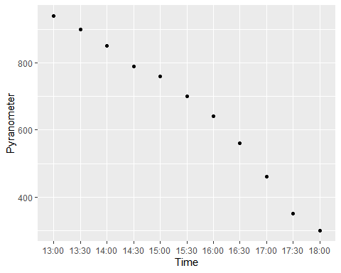
(iv) Plot Pyranometer reading Vs Two
ggplot(data,aes(x=Pyranometer, y=Two_5))+geom_point() #To plot
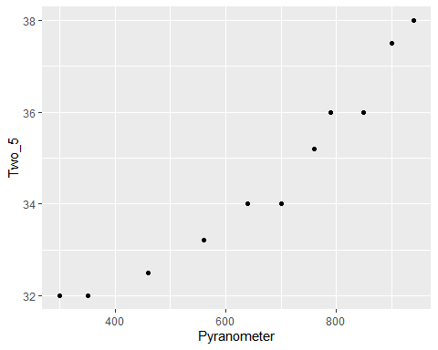
(v) Plot Pyranometer reading Vs Qact
ggplot(data,aes(x=Pyranometer, y=Qact_5))+geom_point() #To plot
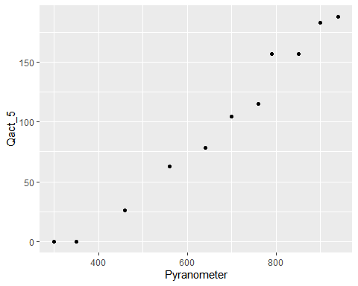
(vi) Plot Pyranometer reading Vs degree of temperature rise
ggplot(data,aes(x=Pyranometer, y=Deg_Temp_Rise))+geom_point() #To plot
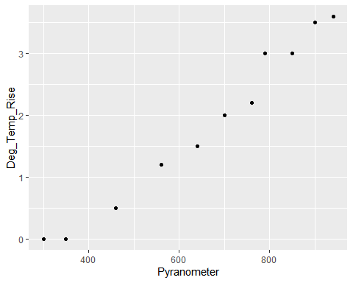
(vii) Determine the best linear fit equation between Pyranometer reading and Two
fit = lm(Pyranometer~Two_5, data)
summary(fit)
##
## Call:
## lm(formula = Pyranometer ~ Two_5, data = data)
##
## Residuals:
## Min 1Q Median 3Q Max
## -103.201 -50.760 7.243 39.107 98.574
##
## Coefficients:
## Estimate Std. Error t value Pr(>|t|)
## (Intercept) -2768.39 327.37 -8.456 1.42e-05 ***
## Two_5 99.11 9.45 10.488 2.40e-06 ***
## ---
## Signif. codes: 0 '***' 0.001 '**' 0.01 '*' 0.05 '.' 0.1 ' ' 1
##
## Residual standard error: 63.29 on 9 degrees of freedom
## Multiple R-squared: 0.9244, Adjusted R-squared: 0.916
## F-statistic: 110 on 1 and 9 DF, p-value: 2.404e-06
(viii) Plot the best linear fit
ggplot(data, aes(x=Pyranometer, y=Two_5)) +
geom_point() +
geom_smooth(method=lm, se=FALSE)
## `geom_smooth()` using formula 'y ~ x'
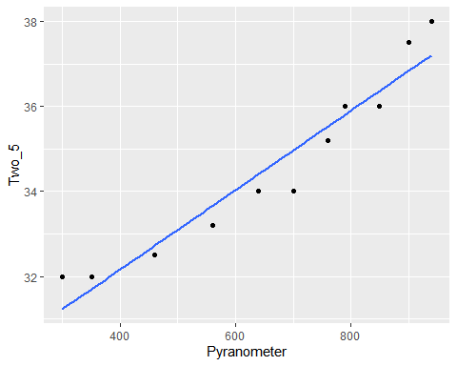
(ix) Determine the Residual Sum of Squares (RSS)
sum((fit$resid)^2)
## [1] 36055.56
(x) Plot the residuals
plot(fit$resid) # Residual plot
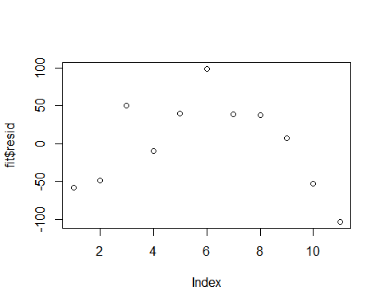
qqnorm(fit$resid) #Q-Q Plot
